Chapter 2, Problem 64.

The potentiometer (adjustable resistor) R_{x} in Fig. 2.126 is to be designed to adjust current I_{x} from 1 A to 10 A. Calculate the values of R and R_{x} to achieve this.
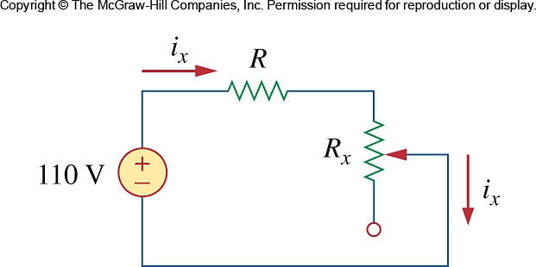

Figure 2.126
For Prob. 2.64.

